**SAMPLE OUTPUTS**

1.Compiling and running the main.c file

Commands used

* pwd :- to display the current working directory
* ls :-to display the files /folders available in current working directory
* Compile :
  + C file :- gcc [name of the file.c] -o [name of .exe file]
    - Eg :- gcc main.c -o mainFile
  + C++ file :- g++ [name of the file.c] -o [name of .exe file]
* Run a .exe file
  + ./[name of exe file]
    - Eg:- ./mainFille]

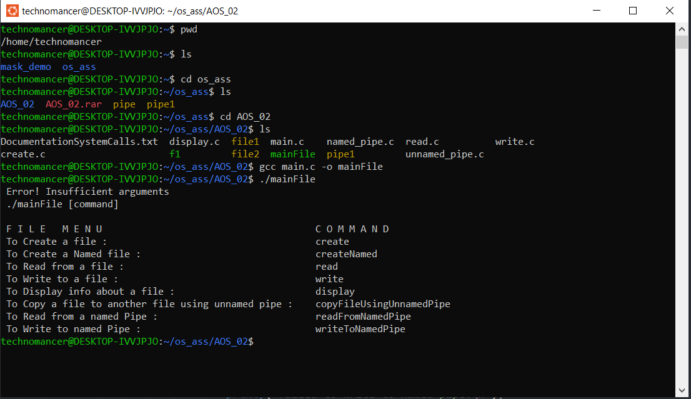

2.To Create a file and Checking Permissions

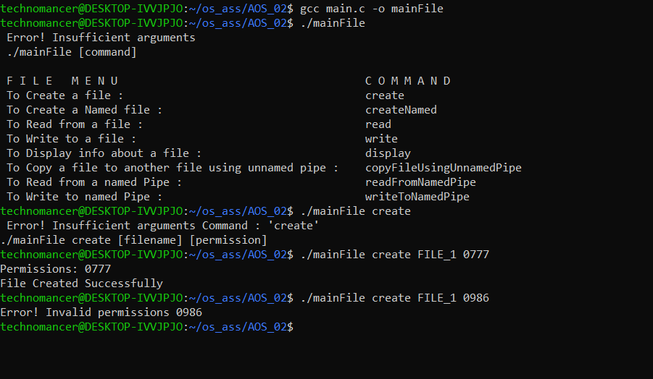

3.To Create a Named Pipe

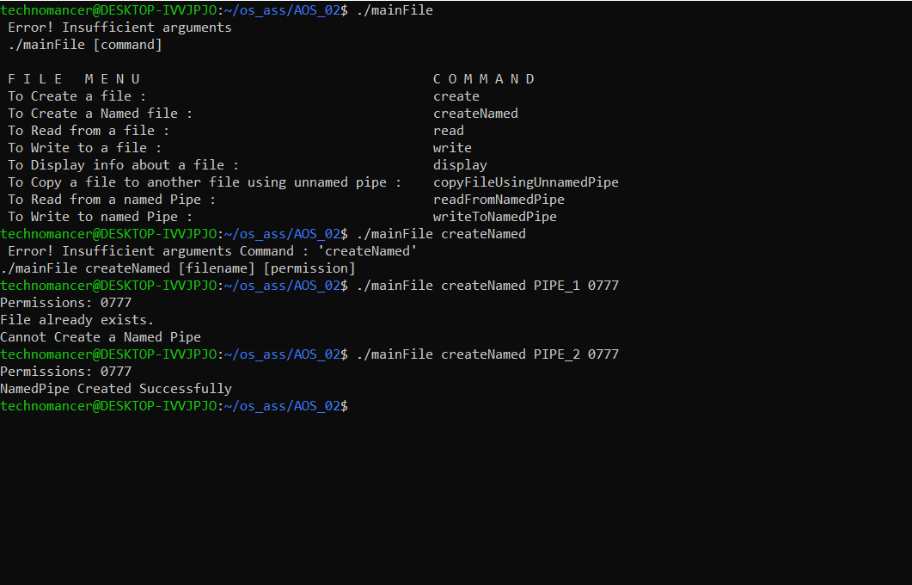

4.To Read from a file

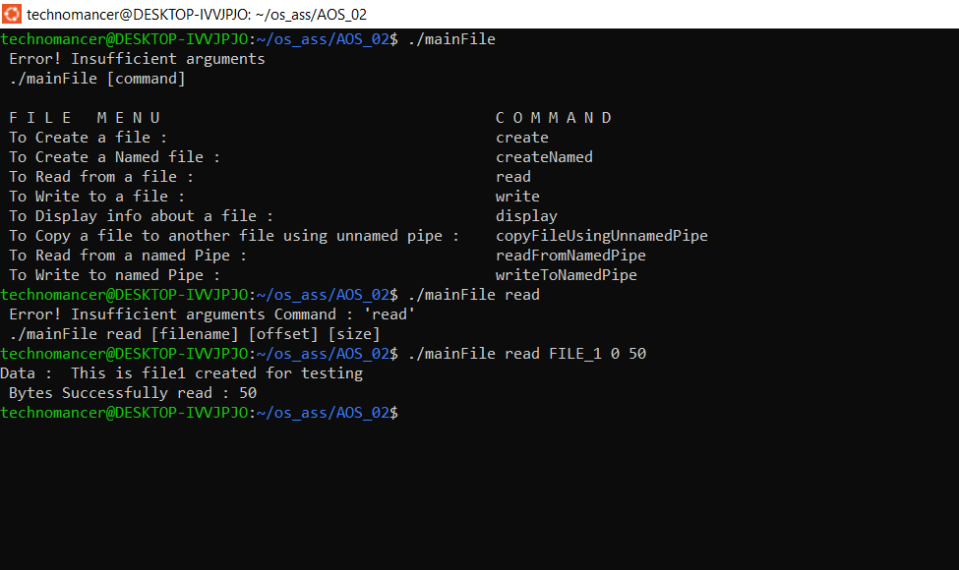

5.To Write to a file

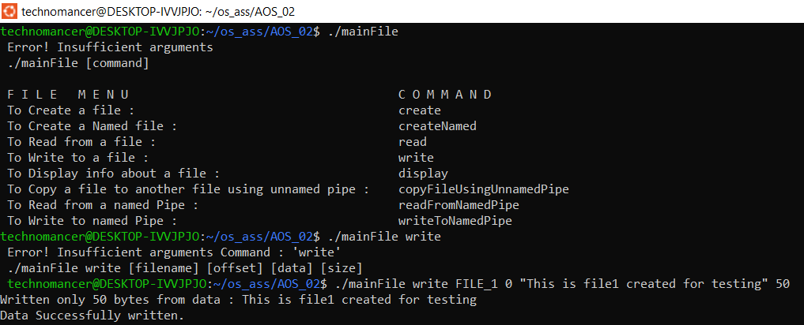

1. To Display information about a file

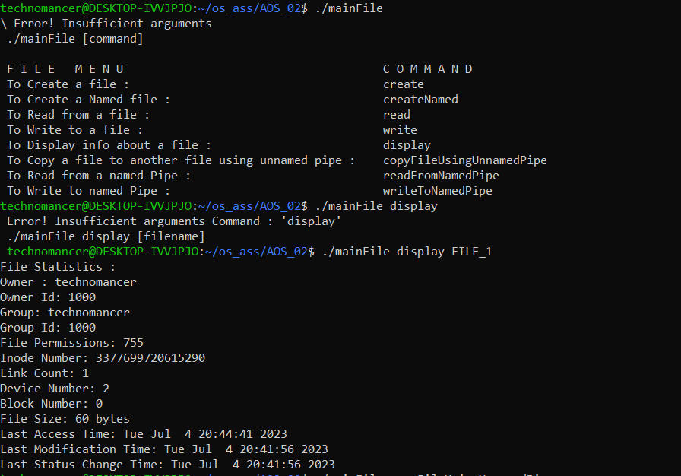

1. To Copy a file to another file using unnamed pipe

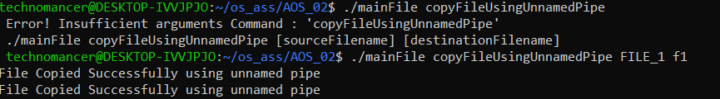

8.Invoking the writeToNamedPipe module

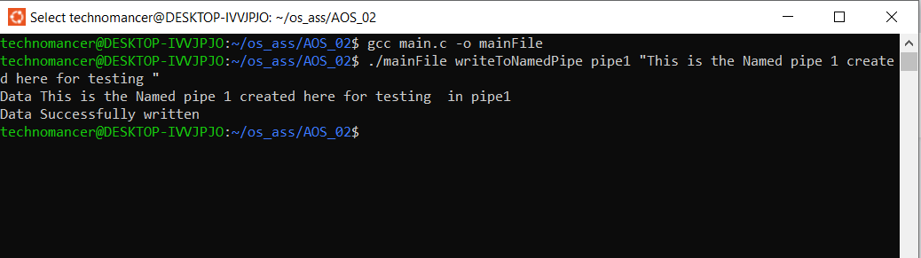

9.Invoking the readFromNamedPipe module

